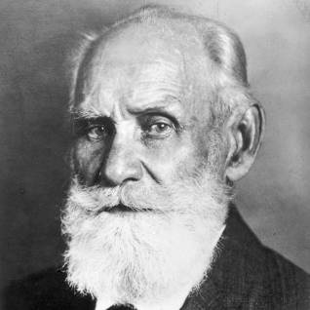Ivan Pavlov (1902)

Sample Group:

Methodology/Procedure:

Results/findings:

Contributions to psychology/society:

Strengths:

Limitations: